Scenario 1: Nima’s experience

**Before:**

Mr. Nima went to the cafeteria and want to have a big lunch. He called for a Yu-Shiang Shredded Pork. When he sit down and enjoy it, he saw a warm in his plate! He feels angry and want to expose his bad experience to the public.

**During:**

Mr. Nima open the app so-called “VentHub”, he write his bad-experience via the app and upload it with a photo. Then click button “vent”.

**After:**

Other people will see Mr. Nima’s bad-experience. And could make a comment or click “up” button, so that it can be seen in TOP100.

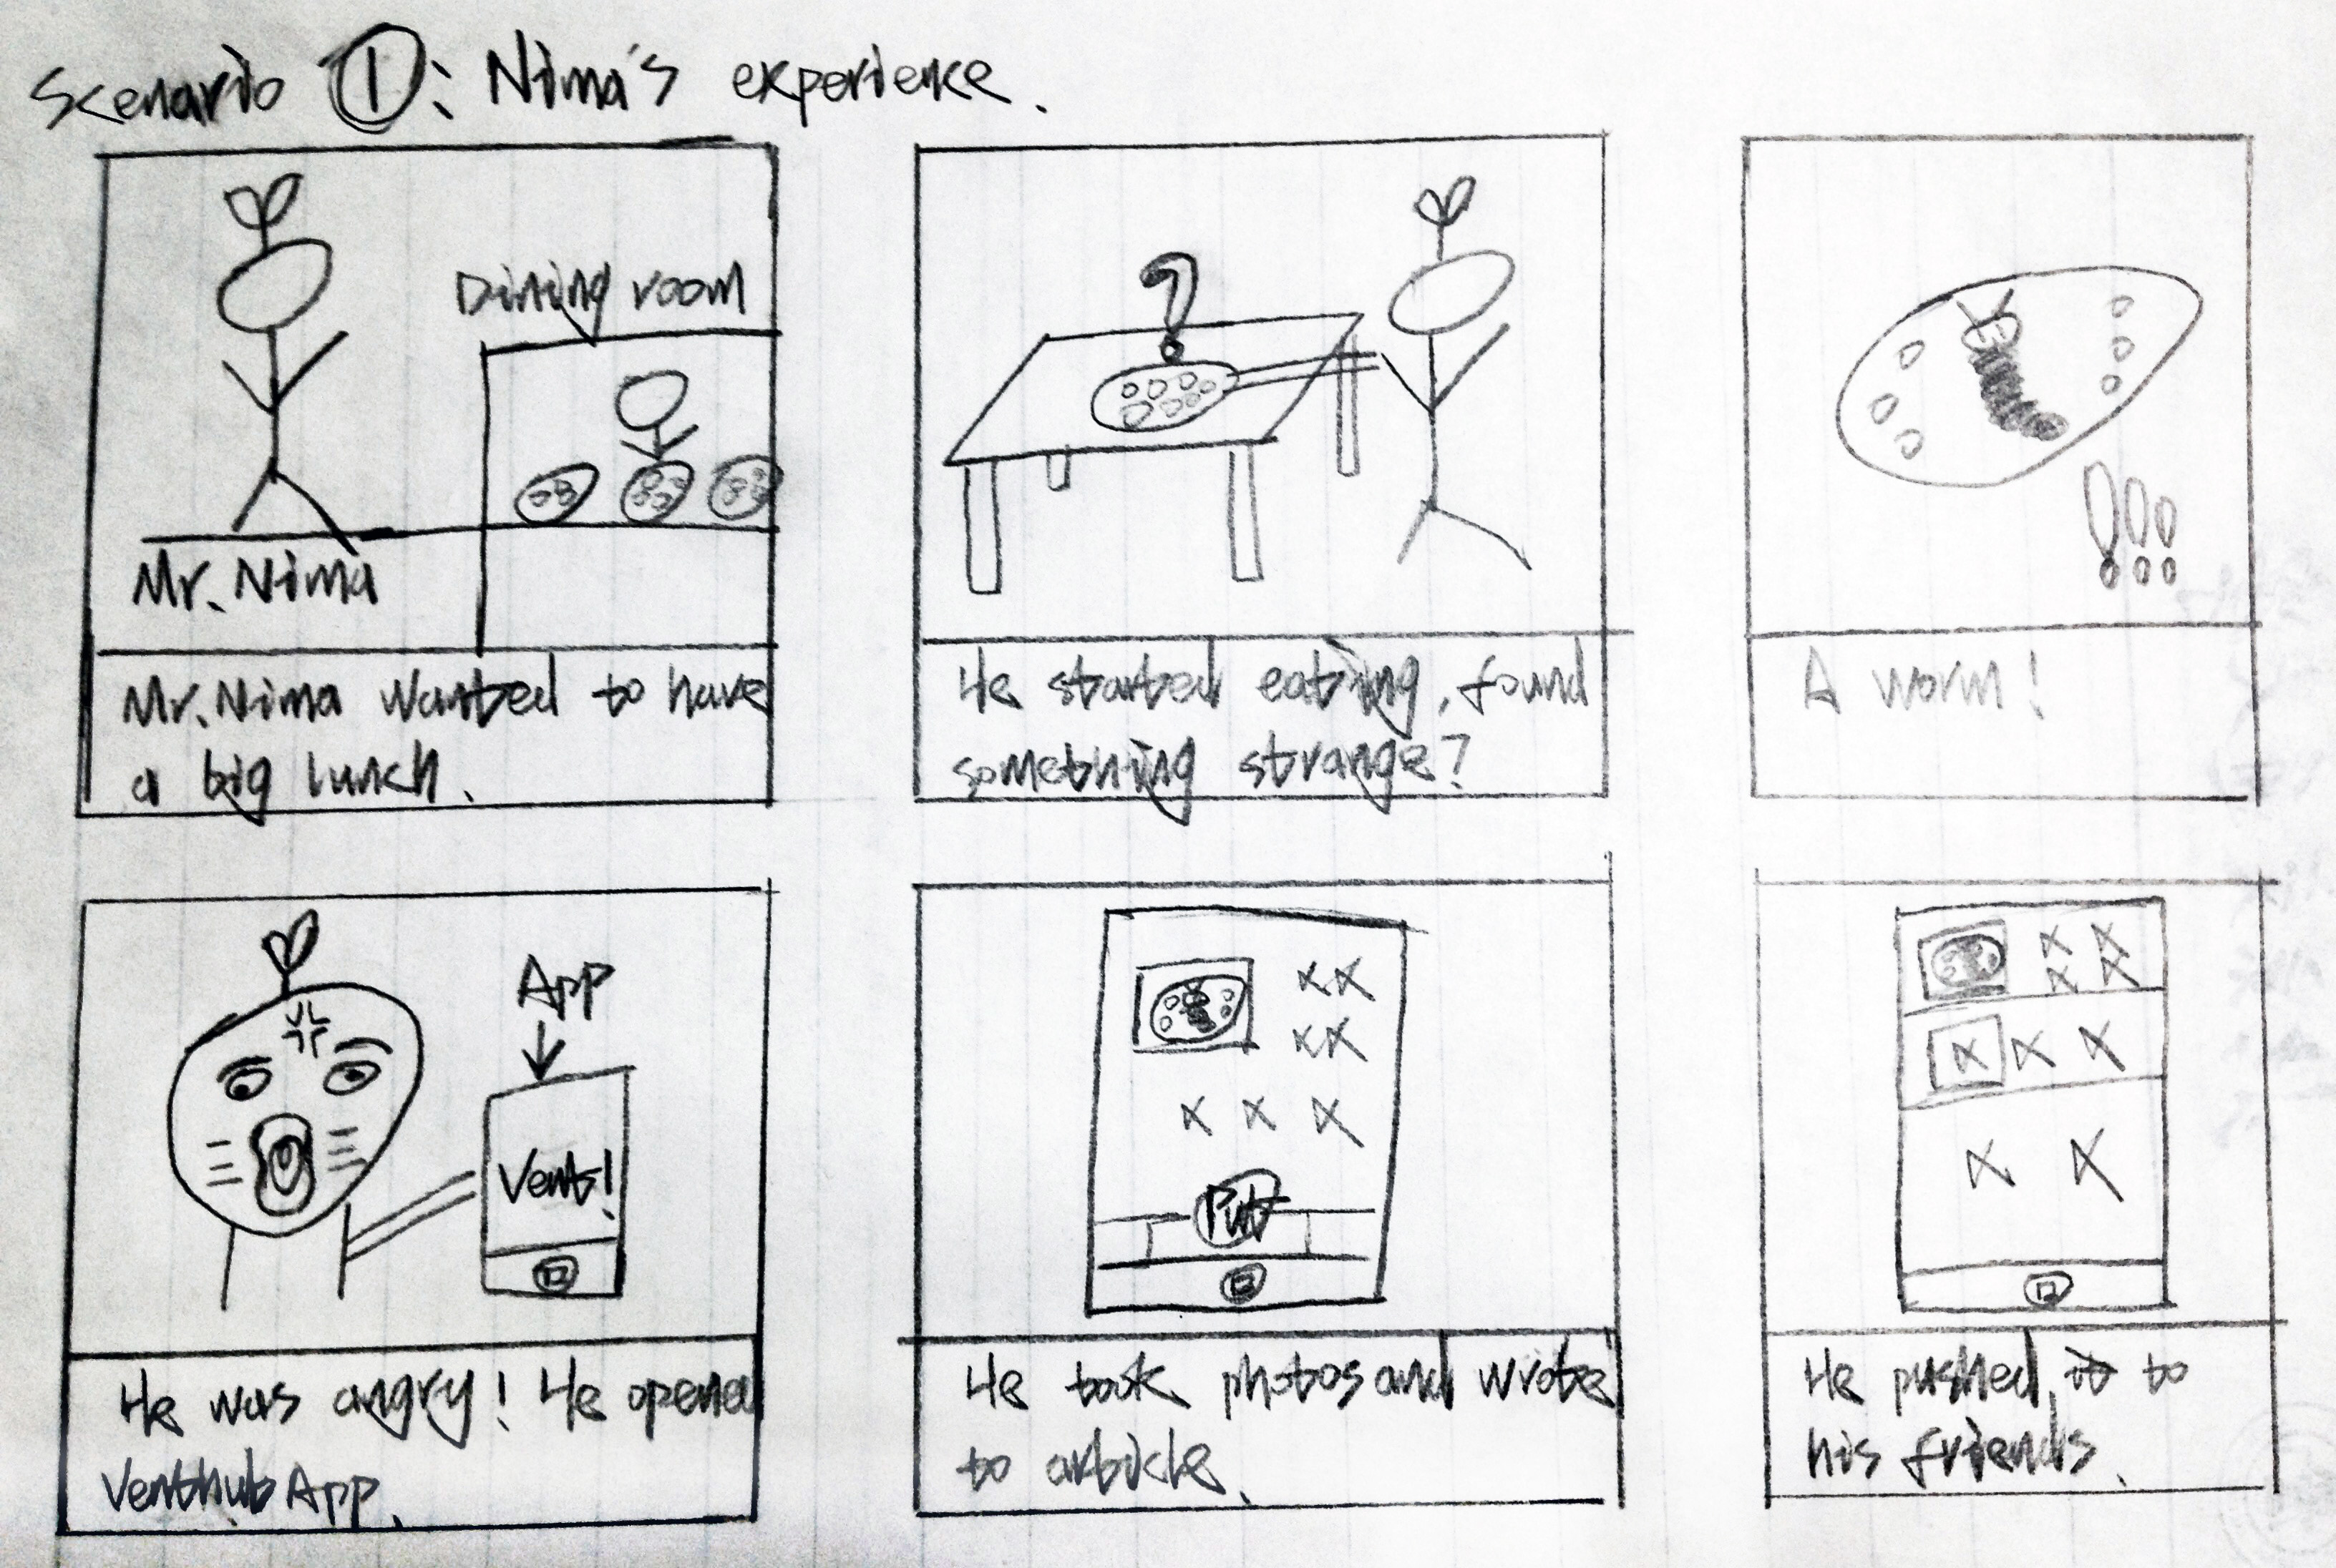

Scenario 2: Nimei’s approve

**Before:**

Miss Nimei feel so boring in her dorm. And she want to see what happened today.

**During:**

She open the app so-called “VentHub”, and she saw that Mr. Nima had a bad-experience in the cafeteria. She feel so panic that she want to let many people know. So she clicked “up” button.

**After:**

Due to the number of “up”, Mr. Nima’s experience is posted on TOP100 and get position #5, so it get widely known.

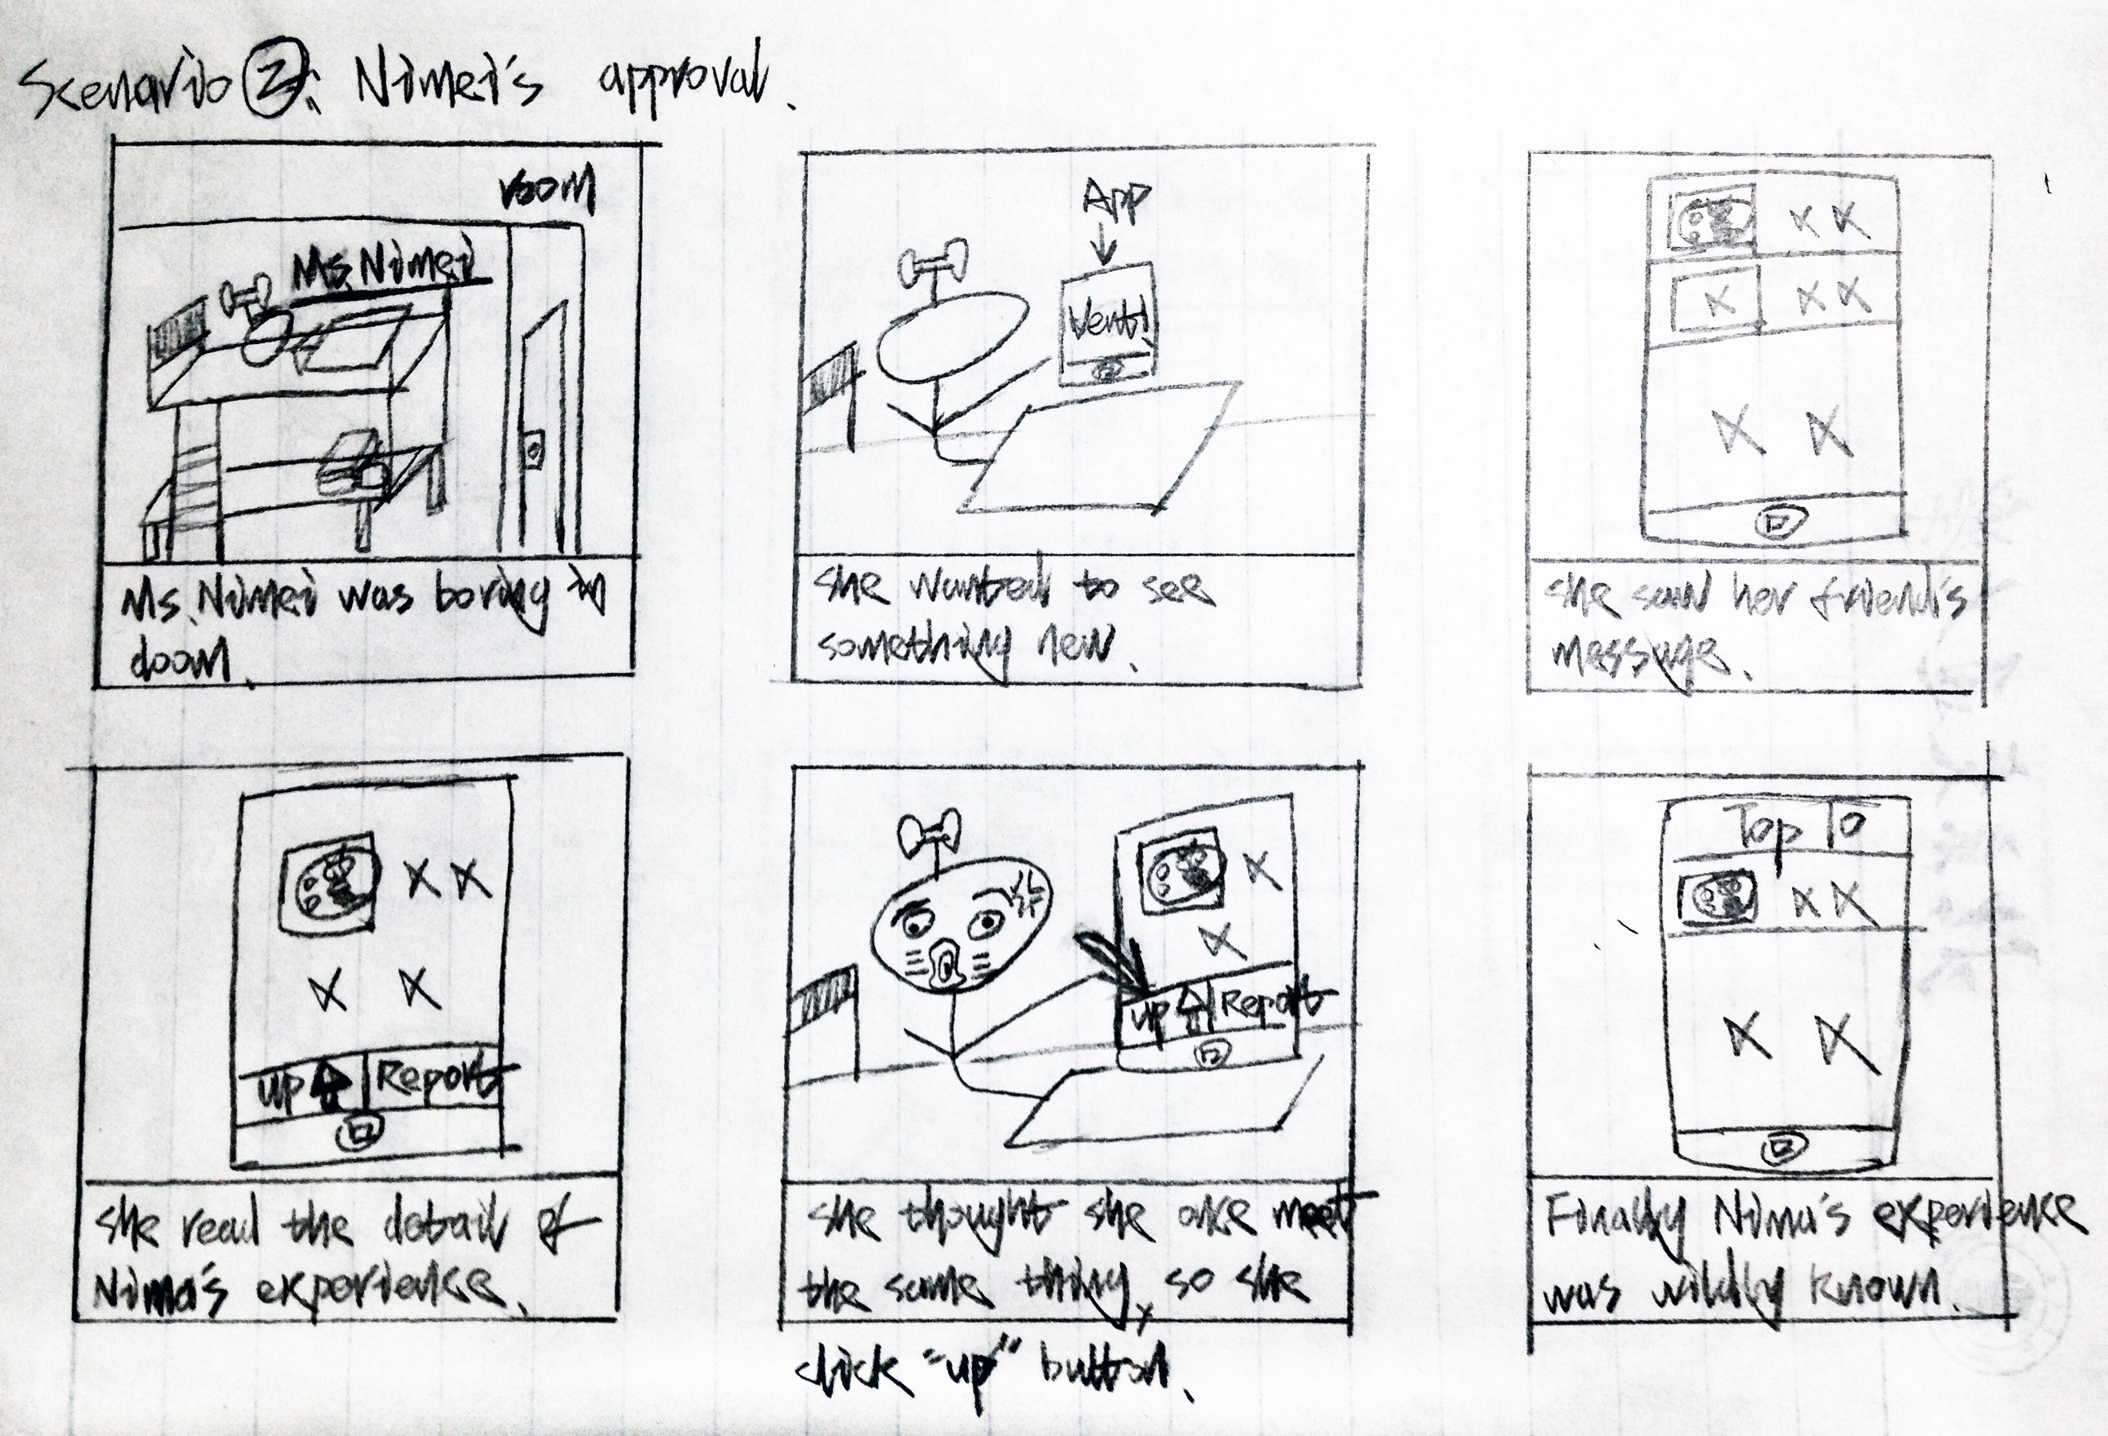

Use Case #1-1:

**Pre-condition:** Application is installed and user didn’t register.

**Description:** User open the application and went to the login layout. Then click “register” button. Application display the register form. User input email, nickname, password, tick the check box to accept our agreement. Then click “register” button to create a user.

**Back-condition:** The user is created. Application display login form. User can login via the email and password.

Use Case #1-2:

**Pre-condition:** Application is installed and has register a user.

**Description:** User open the application and went to the login layout. Enter the email and password. Click “login” button.

**Back-condition:** If email and password is correct, then display the vent list, otherwise notice the user that he input a wrong email and password.

Use Case #1-3:

**Pre-condition:** Logged in.

**Description:** User open the application and display the vent list. Click the “vent” button. Input the content he wants to vent. Choose if he wants to hide himself. Click “send” button.

**Back-condition:** The server get the vent. And store it in the database. The follower can see it in their vent list.

Use Case #2-1:

**Pre-condition:** Logged in.

**Description:** User open the application and went to the vent list. He click a vent message. Then application display the detail about this vent message.

**Back-condition:** The user could see it, and make comment or approve it to TOP100.

Use Case #2-2:

**Pre-condition:** Logged in.

**Description:** User open the application and went to the vent list. And click “TOP100” to went to the “TOP100 Frame”. Server sort it by the number of “up”. And display to the user.

**Back-condition:** User can see the most popular vent message. If it can notice related department, it would be better.

Use Case #2-3:

**Pre-condition:** Logged in. And open a vent message to see it in detail.

**Description:** User feels bad or he has the same experience. He wants more people seeing it. So he clicked “up” button.

**Back-condition:** The number of “up” plus one. If this number is greater than TOP100’s requirement. It could be posted on TOP100 and it could let more people to know.